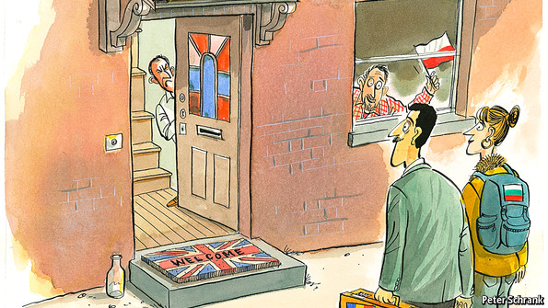

Linking Northern Communities socially, culturally and economically: East European Immigration in Scotland
Event 3 – Roundtable: Newcomers and hometowns: Linking local and migrant communities in Scotland
Scottish Universities Insight Institute, Strathclyde Campus, Collins Building, University of Strathclyde, 22 Richmond Street, Glasgow G1 1XQ
16 February 2014 at 4 pm-6.30 pm
Polish and Scottish migration, in both directions, as discussed in a previous roundtable an a seminar, has a long tradition going back to the sixteenth century. A large Polonia settled during and after the Second World War, and again after Poland’s EU accession in 2004. Other migrant goups, such as Lithuanias, Latvians and Russians, have come to Scotland due to a demand for specific professions, such as in mining and fishing. More recently, Hungarians, Romanians, Slovaks, Bulgarians and Czechs have also moved to Scotland, albeit in much lower numbers than the Poles. In contrast to the Polonia that came after the war and did not feel any motivation to return to their countries under communist rule, the post-2004/2007 new migrant generations can return to their native countries and often take that option, making this partly a temporary migration. However, many who come with their families, settle permanently. Negative press and political pressures that whip up resentment against migrants risk alienating people who have contributed to the Scottish economy, boosted the number of young people in this country, and enriched culture, the food industry, churches and education both locally and nationally. But there are tensions that should not be ignored. Pressure on schools, the NHS, loneliness and psychological problems of migrants who feel excluded by language and tradition, competition for low-paid or part-time jobs among students and locals, conflict on council estates where migrants are sometimes assigned housing (although most rent privately) - none of these subjects should remain taboo. How can mutual understanding and peaceful living together in linked communities be best promoted? Knowledge about the “other”, their traditions, customs, food, holidays, and the disucssion of key events in history can help to overcome prejudices.
Evidence shows that the story has generally been a successful one: Poles and migrants from other new EU member states have been readily absorbed into Britain’s labour market. They are tolerated, even welcomed, locally. Several cities and regions have gone from being ageing, with declining skills to being young, with great aspirations. Areas with many east European migrants have seen a drop in property crime. Britain got younger and better-educated Poles than Germany or America. Many are overqualified for their jobs, and ought to move into more appropriate ones as their social networks become stronger. Ilona Korzeniowska, editor of the Polish Express, a London-based newspaper, suggests Bulgarians and Romanians may fill jobs no longer of interest to Poles (source: The Economist, 14/12/2013). This raises not only economic considerations:

1. To what extent is the Polish model appropriate for other East European migrants’ experience of settlement, cohabitation and integration? 2. Should the example of the largest migrant community, the Poles, be replicated and usefully applied to other migrant communities and across Scottish localities? 3. How are approaches to integration reflected in the specific regions and localities in Scotland that have experienced migrant influx? Does the heritage of other EE migrant groups make integration in Scotland less or more likely, and is it discussed at all? 4. How do the Scottish regions and urban centres benefit from East Central European migrants? 5. Where do cultural clashes and misunderstandings originate, and how do they reflect practices of settlement? 6. What role does the local economy and its oportunities play for the way that migrants are accepted/integrated, and how may cultural expressions be translated into economic resources?
Proposed speakers and discussants are representatives from migrant communities and organisations, as well as Scottish public bodies, local government, private enterprise and academics.

Participants in the Proposed Roundtable:
Prof. Vytis Ciubrinskas (Social Anthropology, Vytautas Magnus University Kaunas, LT)
Dr Neringa Liubinienė (Vytautas Magnus University Kaunas)
Lorraine Cook (COSLA’s Migration, Population and Diversity Team, Aberdeen)
Anna Ruszel (Director Polish Professionals Forum in Europe C.I.C., Edinburgh)
Dr Emilia Piętka (University of the West of Scotland, Mental Health and Psychosocial Support Network)
Martin Fell (owner of Tchai-ovna, Glasgow, business opportunities and food)

Chair: Prof. Karin Friedrich (University of Aberdeen) and Prof. Uli Kockel (Heriot Watt University, Edinburgh)
There will be catering (sandwiches and drinks) and a tea/coffee break.

